

The Evolution of the T'ang Lion and Grapevine Mirror Author(s): Nancy Thompson

Reviewed work(s):

Source: *Artibus Asiae,* Vol. 29, No. 1 (1967), pp. 25-54 Published by: Artibus Asiae Publishers

Stable URL: <http://www.jstor.org/stable/3250289>

Accessed: 11/05/2012 13:07

Your use of the JSTOR archive indicates your acceptance of the Terms & Conditions of Use, available at <http://www.jstor.org/page/info/about/policies/terms.jsp>

JSTOR is a not-for-profit service that helps scholars, researchers, and students discover, use, and build upon a wide range of content in a trusted digital archive. We use information technology and tools to increase productivity and facilitate new forms of scholarship. For more information about JSTOR, please contact [support@jstor.org](mailto:support@jstor.org).

|  |  |
| --- | --- |
|  | *Artibus Asiae Publishers* is collaborating with JSTOR to digitize, preserve and extend access to *Artibus Asiae.* |

NANCY THOMPSON

THE EVOLUTION OF THE T'ANG LION AND  
GRAPEVINE MIRROR

WITH AN *ADDENDUM:* THE «JEN SHOU» MIRRORS BY ALEXANDER C. SOPER

he literature in which lion and grapevine mirrors are discussed is a record of slow disen­gagement from an ancient blunder. In the *Po-kut'u-lut* this class of mirrors, termed *sea-horse*

**T**

*and grape,2* was placed in the Han dynasty. The Chinese connoisseurs failed to recognize these mirrors as products of the T'ang, for they focused attention on the grapevine, a constant feature of the design, assuming that introduction of the grape into China would have had a great im­pact on the culture and art of the period. They concluded that the theme must have originated with the return of the explorer Chang Ch'ien from Bactria in 126 B. C. These mirrors were still ascribed to the Han dynasty in the bronze catalogues and supplements compiled in the eighteenth century by order of Emperor Ch'ien Lung.4

The European scholars who first became interested in the subject inherited the misconception. Friedrich Hirth, in 1896, adopted this description and persisted in ascribing a non-Chinese origin to the motif, stating that the Chinese term for grape, *p'u-t'ao,* could be related to a Greek word of similar pronunciation.' Okakura Kakuzo, the first to ascribe the mirrors to the Six Dynasties period, suggested a Far Eastern origin for the design.6 Berthold Laufer, on the other hand, stated more specifically that the design evolved during the fifth to sixth century under Persian influence.? However, in 1926, Hamilton Bell continued to refer to the *sea-horse and grape* design, and in

1 Wang Fu, *Hsiian-ho po-ku t'u-lu,* A.D. 1125.

2 The failure of Sung scholars to recognize the lions is discussed by Schuyler Cammann in "The Lion and Grape Patterns on Chinese Bronze Mirrors", *Artibus Asiae,* XVI, 4, 1952, pp. 266-269 and p. z68, notes 8 and 9. A number of lion and grapevine mirrors were in the Palace Collection of the Sung Emperor among which were several with a pair of winged, heavenly horses included with the central lions. Evidently the Heavenly Horse was easier to identify than were the lions, and this whole class of mirrors was named after the horse, a subordinate element of the design. It seems that by Sung times the Heavenly Horse, *t'ien-ma,* was no longer popular, having been replaced by the sea horse, *hai-ma,* a motif recently introduced from the Near East. The Sung antiquarians referred to the Heavenly Horse as *hai-ma,* and the Ch'ing scholars, still relying on Sung dating, named the mirrors *Han hai-ma p'u-t'ao chien.*

**3** According to Edward H. Schafer in *The Golden Peaches of Samarkand,* Berkeley, 1963, pp. 141-144, General Chang Ch'ien introduced grape seeds which were planted in the capital and were grown on a small scale for eating purposes. Again in the mid-seventh century tribute gifts of grapes and cuttings of the vine were sent to the capital, and wine was made not only from the imported variety but also from the small wild Chinese grape. By this time the grape was popular for medicinal uses and was the subject of poems by Tu Fu and Liu For the introduction of wine-making into China see B. Laufer, *Sino-Iranica,* Chicago, 1919, p. 232. Also Gustina Scaglia, "Central Asians on a Northern Ch'i Gate Shrine", *Artibus Asiae, XXI, I,* 1958, p. 19, for discussion of the grape motif in the art of India and Central Asia.

4 *Hsi Ch'ing ku cbien,* A.D. 1749; *Hsi Ch'ing hsii chien,* A.D. 1793; and *Ning-shou chien ku,* A.D. 1780.

s Friedrich Hirth, *fiber fremde Einfitisse in der chinesischen Kunst,* Munich and Leipzig, 1896, pp. 12-28. See criticism by Paul Pelliot in "Bulletin Critique", *T'oung Pao,* series z, Vol. 22 (Leyden, 1921), pp. 142-145. A review of the Occidental writings on the lion and grapevine design appears in Cammann, *op. cit.,* pp. 265-269 and notes. For recent etymological de research on the Chinese term for grape, *p'u-t'ao,* see Schafer, *Golden Peaches,* p. 31I, n. 24.

6 Okakura, "Chinese and Japanese Mirrors", *Bull. of the Boston Museum of Fine Arts,* No. 32 (April, 1908), pp. **9-14.**

**7** Laufer, *Jade,* Chicago, 1912, p. 14.

agreement with Hirth attributed the grape rinceau to a Classical or Near Eastern origin, although he did give reasons for assigning a T'ang date.8 Further discussion by Yetts added basically nothing to the already existing theories as to the source of the grapevine motif, but he agreed the mirrors were produced during the T'ang dynasty.9

A re-examination of the origin and evolution of the. lion and grapevine design may be found in recent articles by Schuyler Cammann and Bo Gyllensvard. In two articles,. Cammann speci­fically dealt with the origin, development, and interpretation of the lion and grapevine motif. However, he did not explore the variety of Sui to early 'rang 11 mirrors on which a lion-like creature, not yet combined with the grapevine rinceau, is the dominant motif. Gyllensvard wrote primarily on the style and date of T'ang gold and silver objects, and discussed the evo­lution of the lion and grapevine design only in connection with the floral and rinceau motifs on those mirrors having repousse silver or gilt plaques set into the back.12

At the time these publications appeared, little dated evidence as to the origins and evolution of the motifs had accumulated and the usefulness of studies based on comparisons of style was obviously limited. Gyllensvard considered, as primary evidence for the early dating of the lion and grapevine design, a mirror found within a gilt bronze reliquary during repair, in 1926, of the five-storied pagoda of Horyuji. The reliquary, placed under the central pillar, was thought to have been buried in connection with laying the foundation of the pagoda *ca.* A. D. 607, and so he ascribed the appearance of these two motifs in a unifed design to the early seventh century. The discovery of a monastery courtyard to the southeast of the present one suggests that this is the remains of the original building that was destroyed by the disastrous fire in A. D. 670. More likely the mirror was placed under the central pillar at the time of rebuilding within the following decade. As will be demonstrated later, the evolution of the lion and grapevine motifs in a unified design probably did not occur until at least the mid-seventh century, though cer­tainly by A.D. 692, the date of a tomb in which a lion and grapevine mirror of similar design was recovered.i3

Important new source material for more detailed study of this and other types of mirror design has become available through a series of Chinese catalogues beginning in 1957 14 in which mirrors recently recovered from tombs in several of the major provinces have been illustrated. A number of these were found in tombs said to be of the Sui and T'ang periods; although the data provided in the catalogues is extremely brief, they do refer to find reports in which the evidence for dating is at least summarized.

8 Bell, "Chinese 'Grape and Sea-horse' Mirrors", *Art Studies,* Cambridge, Mass., 1926, pp. 59-7o.

9 Percival Yetts, *The Cull Chinese Bronzes,* London, 1939, pp. 167-173. Yetts suggests that the Chinese employed the character, *hai,* in the sense of foreign, *hai-wai,* acknowledging the non-Chinese origin of the motif.

io Schuyler Cammann, "Significant Patterns on Bronze Chinese Mirrors", *Archives of the Chinese Art Society of America,* IX (New York, 1955), p. 43 ff.; and "Lion and Grapevine Patterns", p. 265 ff.

I, The designation "Sui to early T'ang" refers to the period extending from the founding of the Sui dynasty to the mid-seventh century.

12 Bo Gyllensvard, "T'ang Gold and Silver", *Bull. of the Museum of Far Eastern Antiquities,* No. 29 (Stockholm, 1957), p. 1 ff.

13 Paine, Robert T. and Soper, A.C., *The Art and Architecture of Japan,* Baltimore, 1955, p. 177. For an illustration of the lion and grapevine mirror found at Horyfiji, Umehara Sueji, *HOryiiji goju no to mitsuho no chosa,* Kyoto, 1954, pl. ix; and *Kaogu,* 1964, 6, pl. ix, fig. 11.

14 Wang Shih-lun, *Chekiang ch'u-eu t'ung ching hsuan-chi,* Peking, 1957. *Shensi sheng ch'u-eu t'ung ching t'u-lu,* Peking, 1959. *Honan ch'u-t'u t'ung ching t'u-lu,* Peking, 1959. *Szechwan sheng ch'u-t'u t'ung ching,* Peking, 196o, and *Lo-yang sheng ch'u-t'u t'ung ching,* Peking, 196o. Future reference to illustrations in each publication will cite the name of the province only.

Fundamental evidence concerning mirror design in general is found in the Japanese imperial Shosoin Collection, which contains four exceptionally fine examples of mirrors decorated with elaborate lion and grapevine designs (as well as numerous others done at a more routine level). The dedication of this collection to Todaiji in A. D. 75 6 provides an important *terminus ad quern* for the most highly developed designs of the T'ang period.'

The inscription on mirrors of the Sui to early T'ang period usually does not include a date, with three exceptions.16 Unfortunately, not enough of this type of evidence has accumulated to allow in most cases anything more than a presumption based on analysis of the formal design and of the treatment - naturalistic or abstract - of the decorative motifs.

Another line of attack is provided by the phraseology of some inscriptions which on Sui to early T'ang mirrors appear in a narrow circular band peripheral to the central area. One in­scription, reminiscent of Han formulae, is certainly a type popular during the Sui dynasty (Fig. z). The inscription, composed of only eight characters, simply expresses good wishes for the future of the owner, a "man of Sui".17 The style is entirely different from other long poetic Sui to early T'ang inscriptions,18 and the reference to the men of Sui and the wish for long life seems fitting for the Chinese who were united for the first time in centuries under a Chinese dynasty and held high expectations for the future. This inscription appears on a mirror excavated at Hsian-fu in Shensi, site of the Sui capital, and since several mirrors that are uninscribed but decorated with a similar design have been recovered from tombs of the Sui dynasty, we can be assured that this inscription is typical of the period..9

LATE SIX DYNASTIES TRANSITIONAL DESIGNS

Mirrors produced in the South during the Six Dynasties are characteristically decorated with a holy assemblage of divine beings, centering on Hsi Wang Mu and Tung Wang Kung, and animals organized around the cord knob and paired axially across from each other. A series of alternating circles and squares encircles the outer margin of the central area, and a band of saw teeth divides this zone from the peripheral inscription band. If an outer concentric zone of pic­torial decoration is included, a variety of mythical birds and animals is vivaciously rendered, and sometimes dragons are portrayed pulling the chariot of a divine being or of the deceased on his Celestial Journey.

*'s ShOgin gyobutsu zuroku,* Vol. 14, Tokyo, 1929, pls. 40-43.

**16** See Umehara, *Tokyo taikan,* I, Tokyo, 1945, pls. 8 and 9, both mirrors with dates corresponding to A.D. **65o** included in

the decoration on the rim; and *Po-ku t'u-lu,* 29.15 a, with the date corresponding to A.D. 622 in the inscription.

**17** This eight character phrase yEffiNNAA4.--,Taf appears around the cord knob. For mirrors decorated with similar designs see n. **21.** Four-character phrases reminiscent of Han formulae are included in other inscriptions, for example Tfq"-atW on a mirror in *Tokyo taikan,* Vol. I, p1. 5, and A.-T- g on a mirror illustrated in *Shensi,* pl. 81. See **B.** Karlgren, "Early Chinese Mirror Inscriptions", *Bull. de of the Museum of Far Eastern Antiquities,* Vol. 6 (Stockholm,

1934), PP. 9-79.

**18** See the discussion by A.C. Soper on the " Jen Shou" mirrors in the *Addendum,* p. 55 ff.

**19** *Shensi,* pl. 88 and the mirrors listed under n. **21.**

The design on a mirror in the British Museum (Fig.1)20 is of particular interest in showing certain developments in the decorative repertory which occurred toward the end of the Six Dynasties period. The cord knob is framed by an octagon, and radiating lines describe eight trapezoids which contain various isolated motifs. When compared with earlier mirrors decorated with representations of divine beings and animals, the simplified geometric order of this particu­lar design is novel and striking. The figures of Hsi Wang Mu and Tung Wang Kung appear opposite each other, and the six remaining fields are occupied by two guardian monsters, or *pi­hsieh,* and the traditional creatures symbolic of the Four Quarters. The appearance of this latter group testifies to the renewed popularity of a tradition carrying back to Western Han. In mirror design fashionable from the later part of the first century A. D. on, the four creatures are likely to be absent or to be used in a way that minimizes their cosmological importance. At the end of the Six Dynasties period, they are found again as major decorative and symbolic motifs on the elaborately engraved stone epitaph covers produced in the 5 20's for members of the Northern Wei court, and on the painted walls of the square tomb chambers of Koguryo. The renewed emphasis on this group of Four Directional Creatures was undoubtedly due to the revival of traditional Chinese concepts of the universe and their representation in art.

The outer band of decoration on the British Museum mirror is somewhat damaged, yet a counterclockwise procession of fantastic birds and animals, including the six dragons and the Celestial chariot, can be distinguished. Closer examination of this group, rendered in the Six Dynasties tradition, reveals that some of the creatures are no longer fantastic, but must be the twelve that constitute the symbols of the Chinese zodiac. Beginning nearest to Tung Wang Kung there appear in order, the cock, monkey, sheep, horse, snake, dragon, (the hare, tiger, and ox are probably obscured because of damage) rat, boar, and dog.

How quickly these symbolic motifs, the directional four in the central area and the cyclical twelve in the outer concentric band, were unified in an artistic design is shown by a homogeneous group of mirrors among which the style of the various designs as well as the quality of casting is strikingly similar.21 The entire surface of these mirrors is decorated on one level until at the outer edge a thick rim rises sharply. On some mirrors of this group the traditional Creatures of the Four Quarters are placed in their quadrants around the plain central knob and in the outer

**20** British Museum, reproduced in *Tokyo taikan,* I, pl. 1. A mirror decorated with the same design and inscription is in the Tokyo National Museum. In order to avoid lengthy footnotes, reference will be made to only one publication in which the mirror discussed is reproduced, rather than listing all the examples of one design known to the author. The simpli­city of this method is misleading, for a great number of mirrors are similar in design, dimension, and inscription type. Whether they are products of one workshop and were cast from the same mould is left for the reader to interpret. In some cases striking coincidences of style have been pointed out, and one need only to browse through the following publications to realize the popularity of many designs. In addition to the catalogues and supplements of the Chinese Imperial Collections and the mainland Chinese publications, see also, Liang Shang-ch'un, *Yen ku ts'ang ching,* Vol. III, part **2** and 3, Peking, 1941; Lo Chen-yii, *Ku ching t'u-lu,* Peking, 1916; Tomioka, M., *Tokan kokyo zuroku,* Kyoto, 1924; Umehara, S., *Hakutsuru kikkin shrs,* Kyoto, 1951; *Senoku seisho,* Kyoto, 1934; *Shina kodo seikwa,* Vol. II, part **2,** Osaka, 1933, and *Tokyo taikan,* Tokyo, 1945.

**21** Among this group several types of designs in combination occur. *Szechwan,* pl. 43, recovered from a tomb near Ch'eng-tu, decorated with the four directional and the twelve Zodiacal animals. The twelve animals move clockwise and are well spaced in the proper relationship to the Four Directional Creatures. *Shensi,* pl. 88, recovered from a tomb near Hsian-fu, decorated as the mirror in Fig. **2.** *Shensi,* pl. 87, recovered from a Sui tomb near Hsian-fu; a vine rinceau appears in the center and the Zodiacal animals in the outer band. *Shensi,* pl. 85, recovered from a Sui tomb near Hsian-fu decorated with four lion-like animals in the center and a rinceau in the outer band. *Shensi,* pl. 86, recovered near Hsian-fu ; the cen­tral area is enlarged and decorated with four lion-like animals.

band the twelve animals of the Duodenary Cycle are arranged facing clockwise in compartments separated from the plain rim by a band of broad saw-teeth. However, on several mirrors the additional figures of the two divine beings, Hsi Wang Mu and Tung Wang Kung, and what appear to be two guardian *pi-hsieh* are included in the central design (Fig. z). This combination again demonstrates that the principal motifs of a typical Taoist holy assemblage composition of the Late Han and Three Kingdoms periods have been isolated and recombined with the more recently popularized Creatures of the Four Quarters. Clearly by now the Twelve Animals of the Zodiac were introduced to the Chinese repertory and their representation in art was standard­ized.22 The eight character inscription with the reference to the men of Sui already discussed is included in the design encircling the cord knob of this mirror.

The somewhat unusual feature these mirrors have in common is that the entire design is organized on one level, that of the base of the cord knob. This is in contrast to one of the most consistent features of mirror design since the Han dynasty, where the central area and the surrounding zones of decoration are placed at different levels, each progressively rising from the base of the cord knob to the height of the rim. The particular use of the Twelve Animals facing clockwise, when on most mirrors they face counterclockwise, would suggest that they are products of one workshop. Furthermore, among this group of mirrors with similar designs, the only apparent differences are the varying distinctness of the details and small variations in

**22** A survey of literature on the animal cycle in China reveals that the question of origin still remains to be explained satisfactorily. The debate is supported on the one hand by L. Saussure in "Les Origins de l'Astronomie Chinois : B, Le Cycle des Douze Animaux", *T'oung Pao,* Vol. XI (Leyden, 1910), p. 583 ff., who explains that the group is essentially Chinese; while E.Chavannes in "Le Cycle Turc des douze animaux", *ibid.,* Series 2, Vol. VII (1906), p.5 i ff., and P. Pelliot in "Le plus ancien exemple du cyde des douze animaux chez les Turcs", *ibid.,* Vol. XXVI (1929), p. 204 ff., maintain that the Chinese took over use of the animal cycle from their Turkic neighbors. In an interesting article which appears to have passed with too little recognition, (see "Der ostasiatische Tierzyklus im Hellenismus", *ibid.,* Vol. XII [1912], p.669) F. Boll cites evidence for origin of an animal cycle in Hellenized Egypt and offers a list of twelve animals which are associated with the twelvefold division of time. Several animals on his list do not appear in the Chinese cycle; however, it is important to note that because the animals signify only the division of time and do not relate to specific star groups, it was possible to vary the order and even the animals without altering the symbolism. Thus, the Egyptian ibis and crocodile were replaced by the more familiar Chinese cock and dragon. Evidence for the origin in Hellenized Egypt and transmission across Central Asia is scant indeed. But Pelliot in "Neuf notes sur des questions d'Asie centrale", *ibid.,* Vol. XXVI (1928), p. zoi ff., cites references to an animal cycle in Han texts, and P. Boodberg in "Chinese Zoographic Names as Chronograms", *Harvard Journal of Asiatic Studies,* Vol. 5, No. 2 (June, 1940), p.128 ff., and in "Marginalia to the Histories of the Northern Dynasties, part II: On the Use of the Animal Cycle among the Turco-Mongols", *ibid.,* Vol. 3, No.3 (December, 1938), p.243 ff., has suggested that many zoographic proper names are names of some of the cyclical animals used as chronograms or simple epithets. He lists examples from the third to sixth centuries when use of the animal names seems to have been most common with Chinese of nomadic origin. If the cycle did origi­nate in Hellenized Egypt, one could not agree with him that this practice was common as early as the sixth century B.C.

Although the cycle of twelve may have been popular as early as the Han dynasty, it is significant that these animals were not incorporated into the decorative repertoire of the period. Instead the twelve stems continued to be used in the T-L-V pattern consistent with the abstract and geometric character of the design. Furthermore, during the first half of the sixth century when the creatures symbolic of the Four Directions were revived as principal decorative motifs on the engraved stone epitaph covers and on the walls of the painted tombs at Tung-kou, this group of twelve is conspicuously absent from the decorative scheme. Thus the mirror in the British Museum is a unique and early example where this animal group is found portrayed realistically. In keeping with the Chinese predilection for symbolic grouping, the cyclical twelve are associated with the days, years, and should appear in groups of three properly oriented with the Four Directional Creatures in the following order: the boar, rat, and ox with North; tiger, hare, dragon with East; snake, horse, sheep with South; and monkey, cock and dog with West. Some attempt has been made in the design of the British Museum mirror to group the animals properly for the snake, horse, and sheep are placed near the phoenix of the South. In general few inaccuracies in organization of the twelve animals in the outer band are noted. Yet on two mirrors reproduced the order has been confused. On the mirror in the Santa Barbara Museum of Art the rat and boar are interchanged, and on the mirror in the Freer Gallery, the hare and tiger.

diameter, perhaps caused by the progressive shrinking of the mould used for production in quantity.

SUI AND EARLY T'ANG: DIRECTIONAL CREATURES OR LIONS

A revolutionary feature of design is the use of four lion-like animals in a simplified T-L-V pattern which appears on a number of mirrors, four of which were recovered from Sui tombs in Shensi province.23 The formal arrangement is derived from the traditional T-L-V pattern found on mirrors popular in the first century A.D., where the Four Directional Creatures have a secondary role. At that time the cosmic diagram represented by the abstract geometric motifs did not permit the directional animals to be placed on the north-south, east-west axes; each was therefore placed between the L and the adjacent arm of the V. However, this prototype was not re-used *in toto.* The idea of China, or the earth, represented by the central square around the cord knob, set within the cross marked off by the V-angles, was preserved; but the T and L forms were eliminated. The simplified design permitted the placing of a symbolic figure on each directional axis outside the square, each figure separated by the V (Fig. 3). This change in symbolic design seems perhaps attributable to a change in ideas concerning the cosmos.24

On Six Dynasties mirrors monsters with quasi-leonine faces are seen rearing up in the crowded spaces around Hsi Wang Mu and Tung Wang Kung. These seem to be not lions proper but more likely the kind of chimera, called *pi-hsieh,* "averter of evil", whose function was clearly considered secondary to the powers exerted by the deities they accompanied. The origin of the prominently displayed lion-like beasts of the Sui to early T'ang style was first explained by Schuyler Cammann and is further discussed by Alexander Soper in the *Addendum.25*

Verifiable Sui tombs - one dated 6 - have yielded four mirrors in which lions appear in place of the traditional Chinese beast-symbols. The latter, used at large scale in a simplified V design, have not yet been found in any tombs certainly ascribable to the Sui dynasty, but their frequent use at least by early T'ang is demonstrable through mirrors known to have been pro­duced during the first century of the new regime.26 These dates are, of course, usable only as termini and are at any rate too closely spaced to show the priority of one directional scheme over the other. Yet the design of the Four Directional Creatures may well have been the first to be worked out under new conditions, since it was a never-forgotten tradition already revived for use on stone engravings in the 5 20's.

The designs on mirrors of the Sui to early T'ang period appear in two types of formal arrange­ment :

*In the first type* (Fig. 3) the Creatures of the Four Quarters are set in the simplified T-L-V framework and fill the enlarged central area. A double band of saw teeth separates the inscription

23 *Shensi,* pl. 80, a square mirror recovered from a Sui tomb near Hsian-fu; *Shensi,* pl. 81, from a tomb dated A.D. 611 near Hsian-fu; *Shensi,* p1. 8z, recovered from a Sui tomb near Hsian-fu; *Shensi,* pl. 83, mirror recovered near Hsian-fu; and *Honan,* pl. 91.

24 See Cammann, *Archives,* IX, pp. 47-51; and *Arfibus Asiae,* XVI, 4, pp. 271-274, for a discussion of symbolism.

25 Cammann, *Artibus Asiae,* pp. 270-274.

26 *Tokyo taikan,* I, pls. 8 and 9 with the dates corresponding to A.D. 65o included in decoration on the rim; *Po-ku t' u-lu,* 29.15 a with the date corresponding to A.D. 6z z included in the inscription; and *Shensi,* pl. 89, recovered from a T'ang tomb.

from the center. The designs of two mirrors with the date 65 o,27 included in the decoration on the rim, are cited as the high point in both formal and decorative accomplishment. The geometric elements are carefully balanced without dominating the figures of the Four Directional Creatures, each of which satisfyingly fills its allotted space; and all are subtly drawn into the circular design by decorative fillers, a wisp of plumage or a curled tail, which extend into an adjacent area. The contrasts of static *vs.* fluid, square *vs.* circular, low, relief *vs.* flat surface, all create a pleasing dynamic design. These two mirrors have other features in common — the concentric divisions of the decorated surface, the formal arrangement of the central area, the floral motif which fills the V's, the motif of the border, and the style of the characters in each inscription — which suggest they may be products of one workshop.

Because the lion-like animals were apparently accepted as an orthodox substitute for the Four Chinese Directional Creatures, it is natural that they were employed as a group. The exception, however, occurred when the daring artist who now wanted to represent the center of the cosmos with a naturalistic motif chose to use the figure of a lion. The problem of placement was first solved by outlining in low relief the form of the central lion spreading from beneath the cord knob, replacing the earlier quatrefoil design. A mirror in the Nelson Gallery (Fig. 3)28 decorated in this manner includes a monster's head in each of the V's and the characters *jen shou* appear in the inscription. As has been pointed out in the *Addendum,* one cannot assume in every case that these characters refer to the Sui. However, the style of decoration does suggest that general period.

A freer arrangement of the Four Directional Creatures and the central lion was achieved by eliminating the static square and V's, while the Directional Creatures still appear in the proper relationship on the horizontal-vertical axes. Large conventionalized cloud-shapes replacing the V's fill the spaces between the animals to complete the circular design.29

As long as the artist adhered to the cosmic symbolism, the formal arrangement could not vary. But once the square and V's were eliminated and the formal organization loosened, this symbol­ism was minimized. Thus as seemingly unorthodox a combination of animals and birds became possible as is seen on a mirror in the Nelson Gallery (Fig. 4),30 decorated with birds and animals. The three lion-like animals are quite individualized, and the differences in details of the heads of the two birds indicate that they are the male and female phoenix of the pair called *feng-huang.* It would be impossible to show a third phoenix for there was no recognized group of three; thus to match the third animal the bird-man form of the Indian *kalavinka* was portrayed.

*In the second type* of formal arrangement, the traditional Creatures of the Four Quarters appear in a contracted central zone and the Twelve Animals of the Zodiac are arranged in an outer band added peripheral to the inscription. This type of arrangement appears on a mirror in the Santa Barbara Museum of Art (Fig. 5)3. and should be compared with that in the Nelson Gallery (Fig. 3). The Creatures of the Four Quarters are similar, although they are rendered smaller and

**27** *Tokyo taikan,* I, pls. 8 and 9.

**28** Collection of the Nelson Gallery—Atkins Museum (Nelson Fund) Kansas City, Missouri. Mirror No. 36-12.

**29** *Tokyo taikan,* I, pl. 21 bottom, and mirror No. NB 4197 in the collection of the Royal Ontario Museum, University of Toronto, shows the same circular design minus the central lion.

**3°** Collection of the Nelson Gallery—Atkins Museum (Nelson Fund) Kansas City, Missouri, Mirror No. 42-46/2.

**31** Santa Barbara Museum of Art, Charles Henry Ludington Loan Collection. The cyclical animals appear counterclock­wise. The rat and boar are out of order, the rat normally being associated directly with the Black Warrior of the North.

more compact to fit the compressed central area. There are similarities in other details — the configuration of the Black Warrior of the North, the projection of the tails of the dragon and tiger into the adjacent areas, and the appearance of a monster head in each of the V's. The outer band is divided into panels, each containing a naturalistic figure of one of the Twelve Animals of the Zodiac. In addition, the two characters *jen thou* appear in the inscription on each mirror although the phrasing is otherwise dissimilar. A mirror similar in design and illustrated in *Po­ku t'u-lu32* suggests that all three were products of the same workshop.

The central area of this second type of formal arrangement developed as did the first type : when the geometric motifs were eliminated, the arrangement of the animals and of the secondary decor could assume a freer, circular form. At first, the four points were still designated by symmetry of decorative motifs at the site of the V's. The central area of a mirror in the *Po-ku*

*u-lu* is arranged in this manner, but contrary to usual practice, the Animals of the Zodiac face clockwise.33 On a mirror said to have been recovered from a T'ang tomb in Shensi province 34 the controlling geometric and decorative elements are totally eliminated and the four central animals are freely arranged. However, the twelve in the outer band are arranged in the traditional manner. Complete absence of geometric forms in both the central area and in the outer band appears on a mirror in the Marcus Collection,35 and freedom of arrangement has been extended to the point where the animals in the central area move counterclockwise while those in the outer band proceed clockwise.

As previously pointed out, new motifs were soon introduced into the central design. For example, on one mirror 36 a plumed bird with a crest appears in place of the Black Warrior of the North, opposite the Phoenix of the South, most likely in order to form the celebrated pair, *feng-huang.* The Heavenly Horse also appears in place of the White Tiger of the West. When these and other motifs were employed, reducing the significance of the cosmic diagram, the require­ments of symbolism in the design of the outer band were no longer so strong. Thus on one mirror, the zodiacal animals are not confined to rectangular spaces separated by conventionalized floral designs, but run freely in a counterclockwise direction. Each is distinctly modeled in low relief and is separated from the next by a C-shaped cloud scroll. Further elaboration occurs when the outer band is not decorated with Animals of the Zodiac at all, but with alternating birds and animals, separated by the cloud scroll.37

Still another variation appears in the outer band of a mirror in the Winthrop Collection.38 The four central animals are freely arranged while the outer band is divided into fifteen rectan­gular areas, eight of which are decorated with the *pa kua* trigrams and each of the remaining seven with a single musical *apsaras.*

At first, because the lion-like animals were merely substituted for the Four Directional Creatures, the simplified T—L—V arrangement followed the two basic types of formal design

32 *Po-ku* 29. 15a with the date A.D. 622 included in the inscription.

33 *Ibid., 28.4oa.*

34 *Shensi,* pl. 89.

35 Marcus Collection, now in the Stanford University Art Museum.

36 *Tokyo taikan, I,* pl. 14 (formerly Higginson Collection).

37 *Honan,* pl. 9o, and *Tokyo taikan,* I, pl. 7. Some of the birds and animals appearing in the decoration of the outer band may be the ox, dragon, horse, tiger, and cock of the twelve Zodiacal animals.

38 *Tokyo taikan,* I, pl. 6.

already discussed. On the majority of examples a quatrefoil appears projecting from beneath the cord knob, or the base of the knob is ringed by small petals, and decorative ornaments fill the V's where previously the head of a dragon monster appeared. **39**

At this point it is worth mention that on a number of mirrors, lion-like animals have been portrayed in unusual attitudes in both types of formal arrangement (Fig. 6).40 The lions appear occupied in various actions such as holding in the mouth a rectangular book-like form or fanciful, irregular object; or, swallowing a long snake-like object; or biting or attacking another animal. The significance of these particular lions has been discussed by Archibald Wenley and Alexander Soper with particular reference to Chinese literary sources.41

The design of the directional lions organized according to the first type of formal arrangement followed the same course of development as when the four traditional Creatures were employed, that is, the design became more fluid and conformed to the circular shape. Once this freedom had been achieved, the design of four lions around the cord knob became very popular(E. 4 g. 7).42 A mirror recovered from a T'ang tomb in Shensi province demonstrates that to avoid a static design, the central lion was sometimes placed with the others, all being distributed around the knob, abandoning the axes of the four directions.43 In an apparent return to symmetry, the num­ber was then increased to six, the lions being usually paired, facing each other in groups freely arranged (Fig. 8).44 A variation appears on another mirror from a T'ang tomb where the central area has been divided symmetrically into six trapezoids in which each lion appears facing another (Fig. 9).45

When more than four lions appear in the central area (with directional symmetry correspond­ingly abandoned) there was evidently no longer any symbolic justification for the Animals of the Zodiac, and other motifs were substituted. Generally these were symmetrical floral designs, single or paired birds, or lion-like animals apparently flying or running counterclockwise. Separation of these motifs was achieved either by floral or cloud-like decorative fillers.46 On several examples the knob is ringed by small petals, transforming it into a large open flower, and on one mirror, the knob base is encircled by the confronted bodies of two coiled dragon‑

**39** *Shensi,* pls. 8o-83; *Shensi,* p1. 84, a lion appears outlined under the cord knob. *Honan,* pl. 91.

4° *Chekiang,* pl. 43; *Tokyo taikan,* I, pls. 4 and zi top; and a mirror in the Freer Gallery of Art, No. 55-14. The cyclical animals move counter-clockwise and the hare and tiger are out of order.

**41** Archibald Wenley, "A Chinese Sui Dynasty Mirror", *Artibus Asiae, XXV,* 2-3, 1962, pp. 142-145, and Editor's Note, p. 148. See also a discussion of the lions by A.C. Soper in the *Addendum,* p. 62ff.

**42** Mirror in the Boston Museum of Fine Arts, No. 07.212 and one in the Freer Gallery of Art, No. 17.169; and *Shensi,* pl. 90, recovered from a T'ang tomb near Hsian-fu.

o *Shensi,* pl. 304, recovered from a T'ang tomb near Hsian-fu.

**44** *Honan,* pl. 19; *Tokyo taikan,* I, pl. zo, and a mirror in the Seattle Museum of Art, No. 6-5.

4' Mirrors in the Freer Gallery of Art, No. 30-37, and in the Avery Brundage Collection, No. B6o B576. See also *Tokyo taikan,* I, pl. 15; and *Shensi,* pl. ro5, a mirror recovered from a T'ang tomb near Hsian-fu. Though the tendency was to increase the number of lions in the design of the central area to as many as four pairs, I have not found mirrors typical of the first type of formal arrangement so decorated.

46 *Honan,* pl. 9z, decorated with five lions around a plain cord knob and the animals of the Zodiac distributed in trapezoidal compartments with no inscription band. Mirror in the Art Institute of Chicago, No. 32-47, *five* lions appear around the plain knob and symmetrical floral motifs decorate the outer band; an inscription band is included. *Shensi,* pl. to8, decor­ated with six lions in the hexagonal arrangement, with symmetrical floral motifs in the outer band and two animals in the outer band placed opposite each other. An inscription band is included. See also *Shensi,* pl. 103, recovered from a T'ang tomb near Hsian-fu; *Tokyo taikan,* I, pl. 18; *Po-ku t'u-lu,* 28.39a (these two mirrors are strikingly similar), and *Honan,*

pl. **21.**

snakes.47 Decoration of the rim with geometric forms or conventionalized lobed-cloud motifs is now abandoned in favor of a simple rinceau. Several mirrors with this free type of decor in the outer band were recovered from T'ang tombs and frequently the characters *jen .Thou* are included in the inscription. One must assume these characters were used and admired only for the sentiment expressed.

Simultaneously with the use of the Four Directional Creatures and the lions, floral motifs were also popular. A roundel containing six stylized flowers with stamens radially arranged was clearly adopted from Sasanian Persia. The fullest elaboration of this motif included six roundels, and in the second type of formal arrangement repetitive symmetrical floral designs replaced the zodiacal animals.48 One specimen on which this decor appears,49 in Type One arrangement is so similar in detail, especially the lotus design around the cord knob, the style of characters of the inscription, and the decoration of the rim to the two specimens with the date 65o, that one feels obliged to ascribe this mirror to the same workshop. Thus we infer that the roundel motif was popular at least up to the mid-seventh century.

Apparently this motif was quickly altered. The stylized flowers were replaced by lions in two roundels and phoenixes in two others, each placed opposite the other ;59 or all the stylized flower-roundels were replaced with lions. 51 Final elaboration of this motif in the central area occured when eight lions appeared in modified roundels. The borders of two adjacent roundels were merged so that the enclosed lions face each other.$2 This idea of entwining motifs in the central area in a unified design was carried even further on a mirror which closely resembles another described earlier on which the two dragon-snakes encircle the base of the cord knob.53 The en­twining scheme is accomplished by use of vine stalks which emerge from under the head of each dragon-snake. The vine passes in opposite directions to weave around two lions and a branch then extends to enclose two additional lions on the same side. The whole effect is an interlocking of the vine to enclose the lions.

THE LION AND GRAPEVINE THEME

Finally grapevine motifs were incorporated into mirror design. Among the homogeneous group of Sui to early T'ang mirrors decorated with the Four Directional Creatures and the Twelve Animals of the Zodiac, a simple vine rinceau was occasionally substituted in both the central area and the outer band.5 4 The grapevine, along with other floral motifs, was similarly

47 *Tokyo taikan,* I, pl. 17. In *The Decoration of Mirrors of the Han Period,* Ascona, 1960, by A. Bulling, p. 73 and pls. 56 and 5 8, the so-called *lung-hu* mirrors are discussed which were popular from the late part of the first century to the middle of the second century A.D. Perhaps this type of decoration remained in vogue during the Six Dynasties period, or was at any rate revived during the sixth century for use as decoration on mirrors. Several mirrors decorated with this design alone have inscriptions of the Sui to early T'ang type. See *Honan,* pl. 20, and a mirror in the Cleveland Museum of Art, No. 26.249.

45 *Tokyo taikan,* I, pls. i 1, iz, and 13.

49 *Ibid.,* pl. 13.

59 *Po-ku 28.4ob.*

5' *Tokyo taikan,* II, pl. z (Toma Collection).

52 *Shensi,* pl. loo, recovered from a T'ang tomb near Hsian-fu.

53 *Tokyo taikan,* I, pl. 16. In all details, including inscription, these mirrors are so alike as to be from one workshop.

54 See *Shensi,* pl. 87, recovered from a Sui tomb near Hsian-fu; a vine rinceau appears in the center and the Zodiacal ani­mals in the outer band. *Shensi,* pl. 85, four lion-like animals in the center and a rinceau in the outer band.

employed as an elaboration of the simple vine rinceau. A mirror in the Brundage Collection is interesting for an elaborate and finely executed design composed of interlocked arrangements of the pomegranate vine surrounds the plain knob, while the outer band is decorated with the Twelve Animals of the Zodiac.55

The evolution of these various designs was such that union of the lion and grapevine motifs was inevitable. The decoration on several mirrors provides interesting evidence of the initial experiments with this combination. At first four lions appear in the central area around the plain cord knob and the outer band is decorated only with a simple rinceau of palmette leaves; or the grapevine with the leaves and grape bunches arranged alternately along either side of the undu­lating stem.56 On a mirror recovered from a T'ang tomb four birds appear in the outer band, replacing some of the large broad grape leaves.57

The appearance of the grapevine in the Chinese decorative repertoire is novel. Apparently the Chinese knew of the vine after Chang Ch'ien returned from Bactria, yet the motif did not become popular at the time. The lotus flower and vine rinceau associated with Buddhism was the floral motif *par excellence* during the Six Dynasties period. By Sui times, however, the Chinese quickly borrowed the grapevine which appeared as decoration on imported Sasanian silver vessels and textiles.58 The craftsman interested in the possibilities of three-dimensional design was provided with ample opportunity and challenge for experimentation, continuing the interest in more realistic and plastic rendering of plant motifs already seen in the decoration on door jambs of the late Northern Ch'i caves at Hsiang-t'ang-shan or on the haloes and pedestals of many stone and bronze Buddhist images of the late Six Dynasties period.

The early T'ang was a period of great activity and change. The Chinese armies that broke the power of the Turks in Central Asia secured the overland trade routes to the Iranian and Medi­terranean worlds. Contacts with Persia flourished, and the number of objects which reflect the influence of Sasanian design and motifs testify to the interest with which Chinese craftsmen studied this new artistic influence and to the cosmopolitan taste of their patrons.

The reign of Hsiian Tsung (A. D. 713-75 6) was characterized by a high level of wealth and prosperity. Demand for luxury items stimulated trade as well as production of expensive and beautiful objects. Yang-chou at the junction of the Yangtze River and the Grand Canal was an important commercial and banking center, famous for metal work and especially for bronze mirrors cast there, which the court decreed were to be used as tribute to the emperor.56 Since the mature lion and grapevine design never includes an inscription, it is interesting that the in­scription on the mirror in *Po-ku u-lu60* not only contains a date, corresponding to A. D. 622, but also the statement that a government agency of Yang-chou had commissioned the mirror. So it seems that either during the reign of the first T'ang Emperor, Kao Tsung (A. D. 618-627) or even toward the end of the Sui dynasty, Yang-chou was already a well known center for mirror casting and the practice of making a gift of a mirror to the emperor was common.

**55** Avery Brundage Collection, No. B6oB53o.

**56** *Honan,* pl. 23, and *Shensi,* pl. io6, recovered from a T'ang tomb.

**57** *Shensi,* pl. 109, recovered near Hsian-fu.

**58** Dorothy Shephard, "Sasanian Art in Cleveland", *Bull. of the Cleveland Museum of Art,* Vol. 5x, No. 4 (Cleveland, 1964), p. 82ff. See also R. Ghirshman, "Notes Iraniennes V, Scenes de banquet sur l'argenterie Sassanide", *Artibus Asiae,* **XVI, 1-2.** 1953, p. 51ff. and plates.

**59** E. Schafer, *op. cit.,* p. 18; and Wang Shih-lun, *Chekiang ch'u-t'u tang thing bstlan-chi,* p. 6.

6° *Po-ku t'u-lu, 29.15* a.

The analysis of decoration on mirrors of the Sui to early T'ang phase has shown that though the traditional Creatures of the Four Quarters were still popular in A.D. 65 o, the lion without the grapevine already appeared as part of mirror decor prior to A.D. 6ii. This meagre evidence together with that of the three lion and grapevine mirrors recovered from T'ang tombs,61 the mirror from the Horyuji pagoda, probably re-erected in the 68o's, and the four fine examples in the Shosoin Collection are the few pieces with dates associated available at present on which to base a study of the chronological development of the design.

From the variety of examples, it is evident that during the later half of the seventh century there was a lively interest in experimentation, and varying trends in development of the design were proceeding in different artistic centers. The quality of design and of casting, in general finer than in the case of purely bronze mirrors decorated with other designs, would indicate that the lion and grapevine mirrors were highly prized and appreciated by connoisseurs, as were mirrors decorated with such luxury techniques as the *it' ing-to* type set in lacquer, repousse gilt or silver plaques set within the rim, or mother-of-pearl inlay with finely engraved details. The range of execution is from relative roughness to remarkably fine craftsmanship. Artistic experimentation and invention led to production of mirrors with a wide gamut of effects; from clarity and sim­plicity to great elaboration of motifs which completely fill the available space with fine detail; from low relief to strong three-dimensional effects; and from a deliberate separation of motifs in distinct concentric zones, to a merging of the design from the central area to the rim. An orig­inally static portrayal of birds and animals in conventionalized poses gave way to fluid and highly varied depictions, the birds running or flying and the animals assuming ferocious or humorous postures. An emphasis on clearly indicated broad leaves, indistinct grape bunches, and an un­dulating vine with only four lions grouped around the knob, gave way to a preference for curling leaves, a highly modelled and tapered bunch, and an elaborately twisting vine with many lions, one specimen showing as many as eight, each with a cub or a pair of cubs.62

The lion and grapevine mirrors are characteristically round or square, though some are also lobed or floral shaped. These last are usually decorated with repousse silver or gilt plaques set within the rim, and are often quite small, showing considerable experimentation in shape.63 The usual lion and grapevine mirrors are exceptionally large and heavy. In general they measure from 10 to 24 centimeters in diameter and 1.5 centimeters thick at the rim, whereas mirrors of the Han dynasty are on the average 1 o to 1 8 centimeters in diameter and only o. 5 to 0.75 centi­meters thick at the rim.

The decorated surface is divided into a series of concentric zones around the cord knob. The problem of where to place and how to represent the central lion was finally solved by modelling the cord knob in the form of a crouched lion in high relief. The lion may be realistically portrayed with the feet, a mane, a bushy tail, and prominent spine clearly indicated. The head is directed as if the animal were looking straight ahead and the body well modelled and individualized with markings of fur. Elsewhere the lion may be less finely modelled and appears almost doglike, with pointed ears which stand erect, and the head and eyes turned as if the animal were looking up‑

**61** *Shensi,* p1.109, recovered from a tomb near Hsian-fu; *Shensi,* p1. 106. *Kaogu,* 1964, 6, p1. ix, fig. II, and pp. 294-296; a "grape and sea-animal" mirror found in the tomb of a man who died in A.D. 692.

62 *Tokyo taikan,* I, pl. 28, and II, p1. 97. Also see *Shosain gyobutsu zuroku,* 14, p1.41.

63 P.Yetts, *The George Eumorfopoulos Collection,* II, London, 193o, for examples of small mirrors of various shapes.

ward. The wide variety of representation may be attributed not only to individual preferences of artists and workshops, but also to the fact that the Chinese were quite unfamiliar with the real lion. The animal is not indigenous to China and its first mention in Chinese records refers to the gift of a lion as tribute from Parthia in A.D. 87. This practice continued during the Sui and T'ang dynasties, when the number sent as tribute to the Chinese capital from the Central Asian states increased considerably.64 Yet, the Chinese artist seems not to have relied on sketches from life, but merely to have copied lions familiar in Buddhist art or conventionalized types based on traditional Chinese representation of imaginary beasts. On several mirrors the twisted body of a dragon has replaced the lion knob.6s

The central area of the design varies in diameter depending on the number of motifs incorpo­rated. A simple arrangement consists of four lions around the knob. At the other extreme there may be as many as eight with cubs. Frequently found combinations are:

1. four or five lions moving either clockwise or counter-clockwise around the plain or lion-shaped knob (Fig. 1o);
2. three to four pairs of confronted lions (Fig. II);
3. six to eight lions, each circumscribed by the vine stem;
4. lions arranged with their heads facing alternately toward and away from the knob (Fig. i z)
5. pairs of lions combined so as to face each other in opposing directions (Fig. 13); and
6. lions accompanied by other motifs, such as paired phoenixes, dragons, the Heavenly Horse, and accompanying birds (Fig. 1z).

When four central motifs occur, they conform either to the horizontal-vertical or the diagonal axes. In this case the layout of the outer band serves to emphasize either the same axial arrange­ment as the center's or its opposite. When six to eight central motifs appear, they are still arranged on a series of diagonal axes, but the relationship with the outer band is less apparent.

The ridge dividing the central area from the outer band is rendered in one of three ways; either narrow and double lipped (Fig. o); rounded and decorated with a single row of pearling (Fig. iz); or vine-shaped with attached tendrils, leaves, and grape bunches (Fig. 14); Just outside this ridge there may be a raised narrow band, a vestige of the inscription band on Sui to early T'ang mirrors. Occasionally this area is maintained as a separate decorative field, in which small butterflies, insects, and plant forms appear (Fig. 13); or more often branches of the vine origi­nating in the outer band appear to grow and festoon across this raised band, stopping just short of the dividing ridge (Fig. i z).

The outer band presents the greatest variety of animal, bird, and insect motifs which may be analyzed according to the number and the combinations in which they appear. A simple arrange­ment utilizes four birds portrayed as seen from above with wings spread or as from one side. The multiplication of motifs proceeds to five, six, eight, ten, twelve, sixteen and eighteen, and among the square mirrors from eight to twenty-four motifs. When only four to six motifs occur, ele­ments of the vine are evenly spaced and form part of an alternating sequence. The leaves and grape bunches at the outer margin of the central area and at the inner and outer margins of the outer band are often logically increased in relation to the number of motifs both in the center

**64** B. Laufer, *Chinese Pottery of the Han Dynasty,* Leyden, 2909, pp. 236-238.

65 *Hsi Ch'ing ku-chien,* 40.29 a. Mirror in the Museum of Koln, No. 227o.

and in the outer band. But generally the aim is clearly to create an evenly spaced decorative design. Similarly, the arrangement of animals and birds in the outer band seems first to be gov­erned by requirements of good design within that area and then by the need to balance with the central area.

The choice of motifs in the outer band includes alternating animals and birds, birds and insects or pairs of animals and birds. Also there may be repeating groups, such as paired birds and an insect. On square mirrors the corner will be filled either by a bird seen from above or from the side, or a broad leaf, and the remaining motifs are distributed along each side.

On several mirrors the Twelve Animals of the Zodiac appear. It is interesting that this group is combined on some examples with lions in the central area or with other groups such as paired lions and phoenixes, or paired phoenixes and dragons.66 Due to the manner in which the imagi­nary beast or lion was incorporated into mirror design, it is evident that the initial use was as a substitute for the orthodox group of Directional Creatures. In the mature lion and grapevine pattern, this symbolism is all but obscured, yet the occurrence of the Zodiacal Animals implies that traditional Chinese ideas of directional symbolism were still associated with the design.67

The outer rim of lion and grapevine mirrors is narrow and elevated above the outer band. Generally this area is decorated with repeated cloud motifs, or a simple vine rinceau.

The arrangement of concentric zones in an integrated design is varied, yet several general groups can be distinguished. The first group of mirrors (Fig. to) may be round or square and the concentric zones of decoration are clearly defined. A varying number of lions surround the lion knob, and as previously described additional motifs such as paired dragons, phoenixes, or heavenly horses may be included. A variation among this group occurs when the knob is left plain and the central area is decorated with four or five lions or three to four pairs (Fig. It). An additional characteristic of this group is the raised narrow band, which is often maintained either as a separate area of decoration or with the decor from the outer band extending over it (Figs. iz and 13).

In the second group the zones are less distinct (Fig. 14). The knob is lion-shaped, and the central area and outer band merge because of the replacement of the separating ridge by a vine in low relief from which leaves and grape bunches extend into each zone.

The third group of mirrors is lobed or floral shaped, decorated with silver or gilt plaques set within the rim. The design emphasizes the shape, and no distinction of zones is apparent.

Although the lion and grapevine theme was favored during the seventh and early eighth centuries, other designs were also popular. Initially inventive and varied, these designs were soon standardized and became less interesting. Cammann states that by the middle of the T'ang dynasty if not long before, it was customary for the bride to carry a bronze mirror in her lap to guard against evil influences as she rode to the house of the groom. The ceremony took place there and later the mirror was hung over the marriage bed to ward off evil spirits and to insure happiness and an abundance of children. The decoration on a great number of mirrors of this

66 *Hsi Ch'ing ku-chien, 40.29-34; Honan,* p1. 22; Avery Brundage Collection, No. B6oB600; *Po-ku* 29-29b; Musee

Guimet, No. MNL-AA 125o, and two mirrors in the Museum of KOIn, Nos. 2230 and 2270.

67 Symbolism of the lion and grapevine design has been thoroughly discussed by S.Cammann in *Artibus Asiae,* XVI, 4, pp. 282-290 and notes.

period employs a variety of auspicious birds, animals, and insects appropriate to marriage sym­bolism.68

A group of mirrors with pictorial designs not represented in the ShOsain is interesting for iconographic and historical reasons. Instead of motifs variously arranged, traditional Taoist and Confucian subjects are portrayed such as Cheng 0, Goddess of the Moon, with the Toad and Rabbit pounding the Elixir of Life; Confucius meeting with Jung Ch'i-ch'i at the foot of Mount T'ai or the Taoist Hsiao Shih playing the Ch'in with the dancing phoenix.69 Generally these are not outstanding in quality of design or craftsmanship. It would appear that the inventiveness formerly indicated by the variety of designs and shapes of mirrors and even their popularity, declined after the mid-eighth century, coincidental with the political disorders of the time brought on by the rebellion of An Lu-shan, the burning of Yang-chou in A.D. 760, and the sack of Ch'ang-an by the Tibetans in 763. The subsequent decline of the economy apparently led the next Emperor Su Tsung (r. A. D. 75 6-763) to discourage the making of mirrors which involved special processes; and Emperor Te Tsung (r. A. D. 780- 8o 5 ) decreed that mirrors made in Yang-chou for the purpose of tribute to the Emperor should be discontinued. Because copper was scarce, an edict was issued in 793 forbidding the sale of bronze weapons and vessels, and permission was given for the mining of copper wherever found.7° The metal was requisitioned by the government for coinage and mirrors were the only bronze objects allowed to be cast by the craftsmen. This limited historical evidence, and the appearance of traditional and routine subject matter suggest that the great demand for production of mirrors and in turn the inspiration for artistic experimentation spanned little more than a century and a half, of which the mirrors decorated with the lion and grapevine design are exquisite examples.

The artist of the day was particularly concerned with arrangement of the various motifs in a balanced design consistent with the shape of the mirror and with realization of the forms in as three dimensional and plastic a rendering as possible. Several mirrors reproduced show how difficult it was to achieve a completely satisfactory composition.

The design on the mirror in the Chicago Museum (Fig. 1o) shows four lions arranged care­fully on diagonal axes around the lion knob, and this central area is separated from the outer band by a sharp ridge. The outer band is decorated with alternating insects and birds, and al­though the motifs in each area are well spaced and clearly defined, they remain isolated against the thin vine stalk. The design appears rigid and static compared with the mirror in the Denver Museum (Fig. 14). Organization of the central design on this mirror is completed by including a bird between each two lions, thus creating a more continuous and rhythmical relation of the lion figures. This movement is sustained by rendering the vine as an organic, undulating stalk from which leaves and grape bunches grow and festoon both the central area and the outer band. In the outer band the alternating insects and birds are shown in various poses and the subtle placement of the leaves, both curled and open, and of the grape bunches completes this exceptional design.

**68** Cammann points out that many motifs associated with marriage symbolism, auspicious birds, animals, and insects, are included in the designs on some lion and grapevine mirrors. Certainly these motifs were popular, and it is likely that on some mirrors, especially those depicting lion cubs, this symbolism was intended.

**69** *The George Eumorfopoulos Collection,* II, pls. **20** bottom, 3o, and 31.

7° Wang Shih-lu, *op. cit.,* p. 6.

Although the design could only be rendered in varying degrees of relief, the problem of how to freely model and group the lions was a continuing challenge to the artist. The central lions on the mirror in the Minneapolis Institute of Art (Fig. i i) are portrayed in lifeless, stylized poses, and the attempt to depict the growing vine has only succeeded in reproducing an affected curling and twisting. Little interest is shown for the subtle placement of animals in the outer band, and the attempt to show them leaping through the vine is scarcely convincing. In contrast, the paired central lions on the mirror in the Boston Museum (Fig. 13) are shown in vigorous and playful poses, a few turned on their backs, against the vine background. The rich and varied design of the outer band is carefully balanced compared with the over elaborate and fussy design of the mirror in the Brundage collection (Fig. i z).

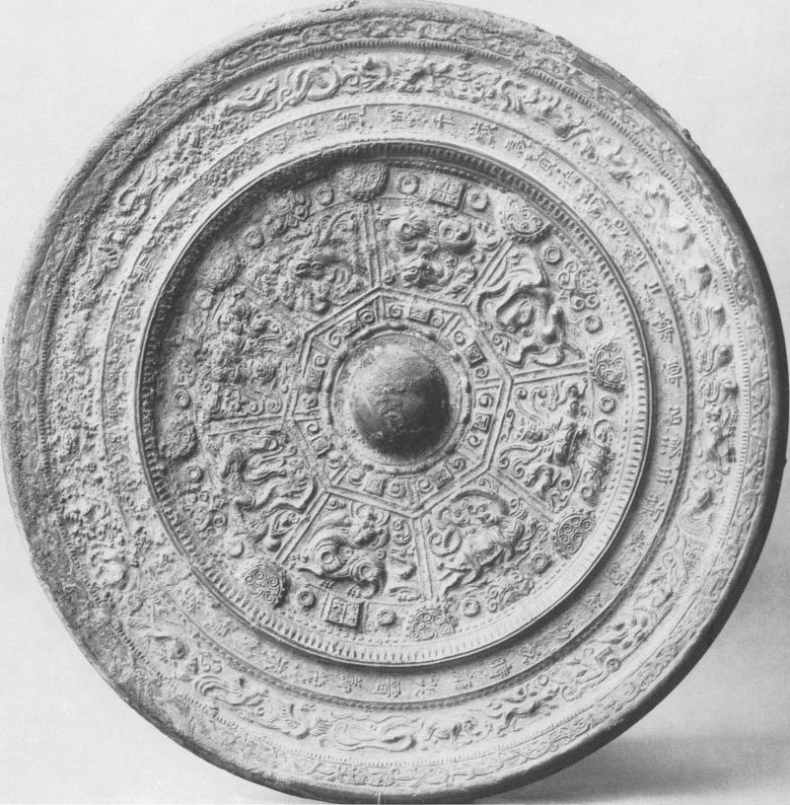

Fig. i Late Six Dynasties Mirror  
*Courtesy of the British Museum*

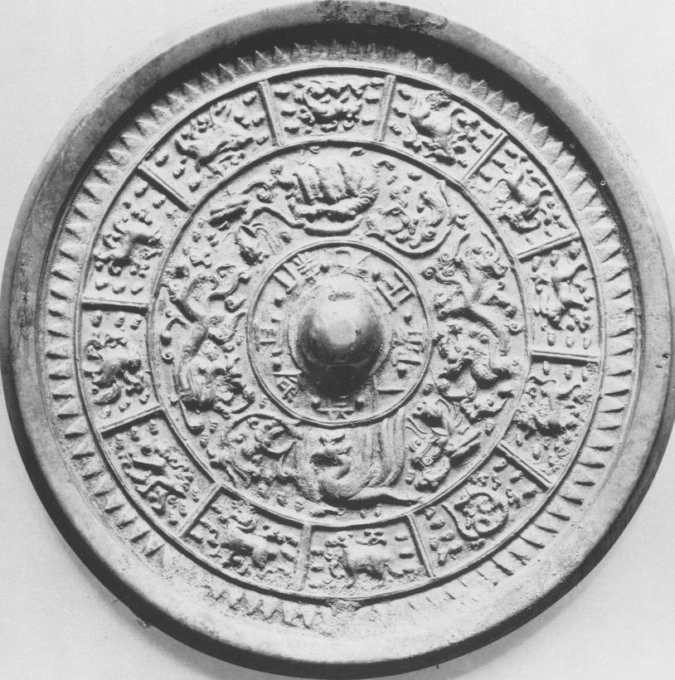

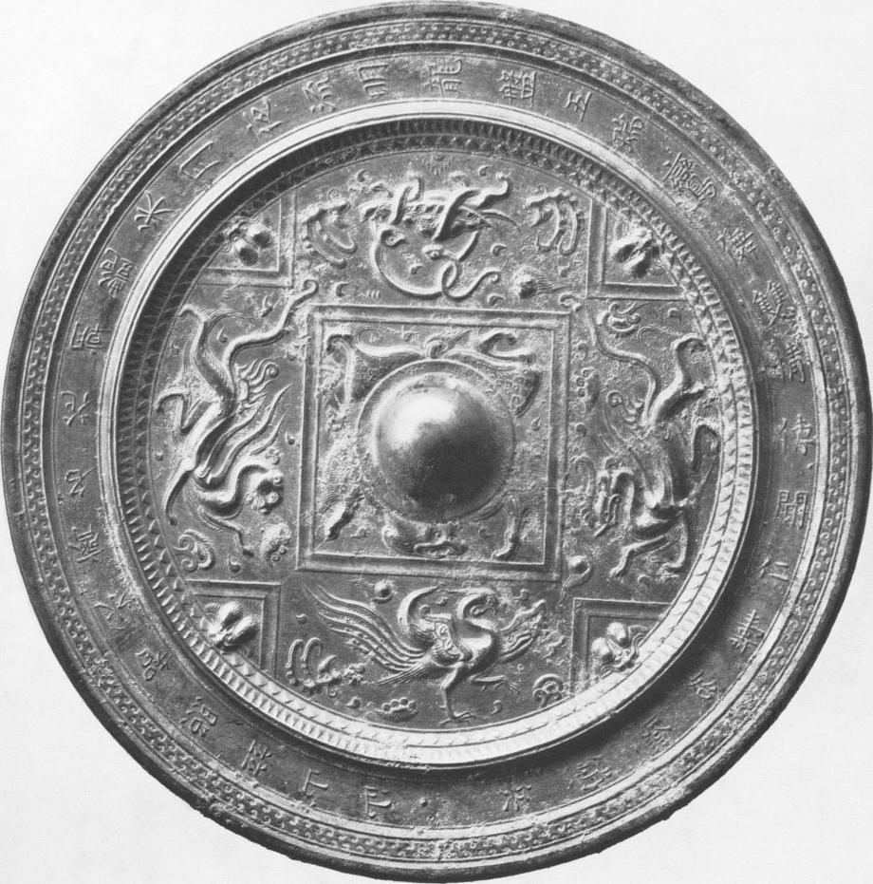

Fig. 3 Sui to early T'ang Mirror with the Four Directional Creatures  
*Nelson Gallery-Atkins Museum (Nelson Fund)*

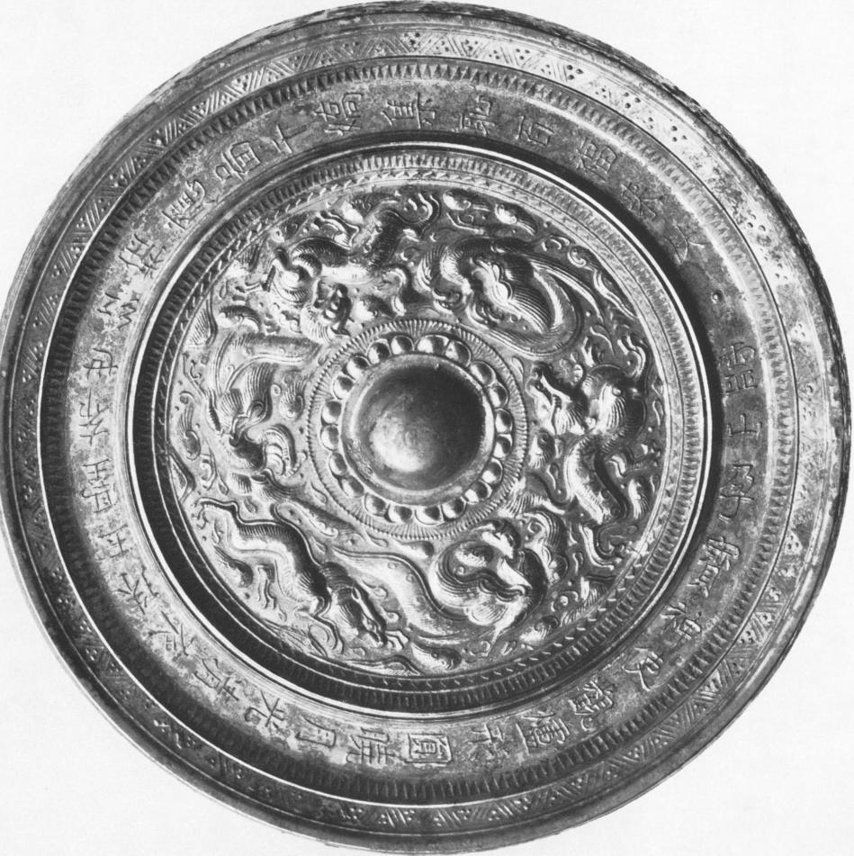

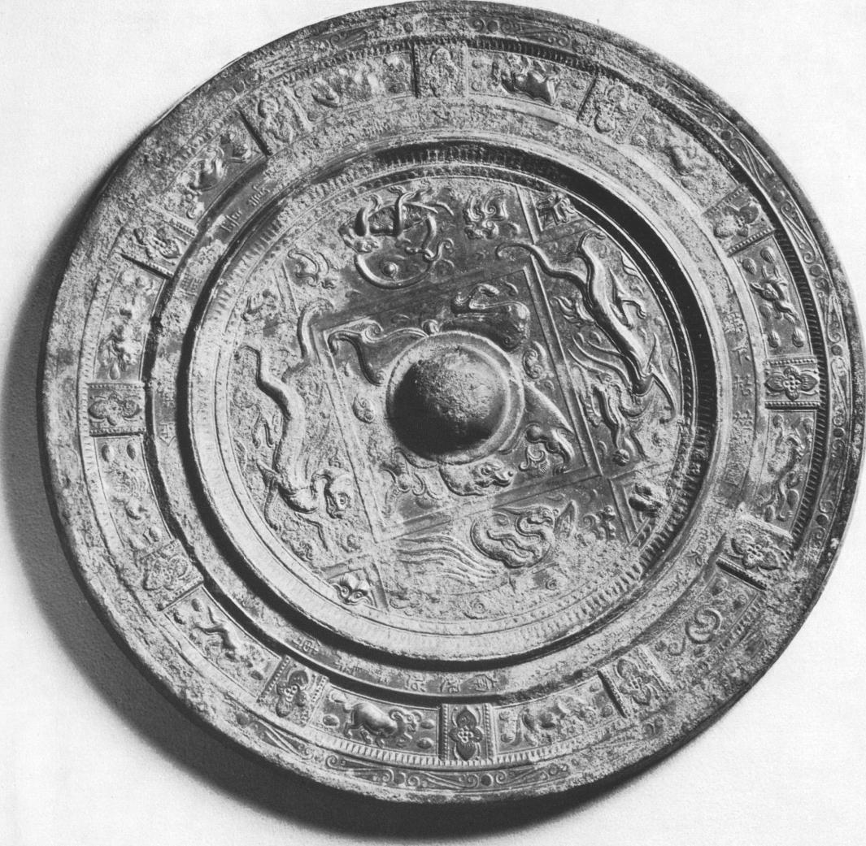

Fig. 5 Sui to early T'ang Mirror with the Four Directional Creatures and the Twelve Zodiacal Animals  
*Santa Barbara Museum of Art, the Charles Henry Ludington Loan Collection*

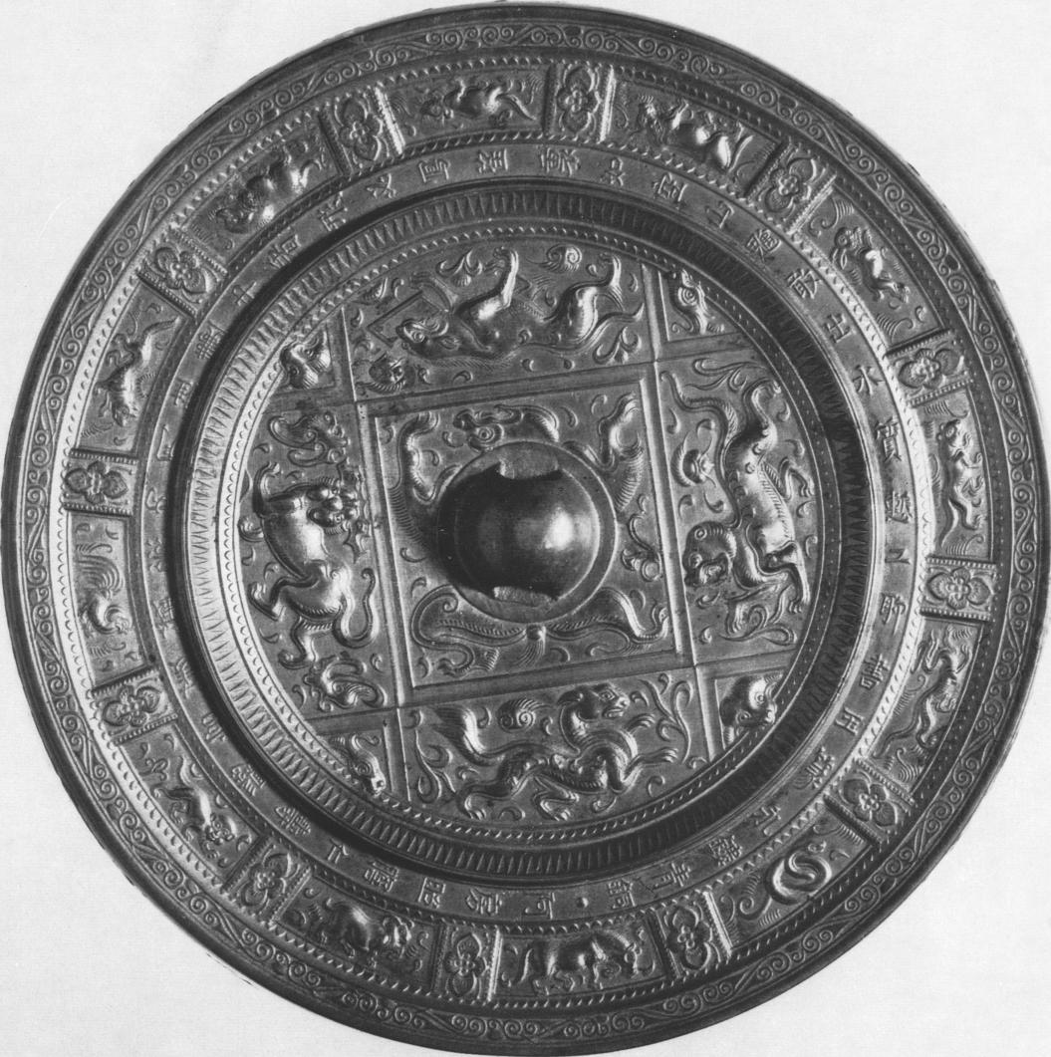

Fig. 6 Sui to early T'ang Mirror with Lion-like Animals and the Twelve Zodiacal Animals  
*Courtesy of the Smithsonian Institution, Freer Gallery of Art*

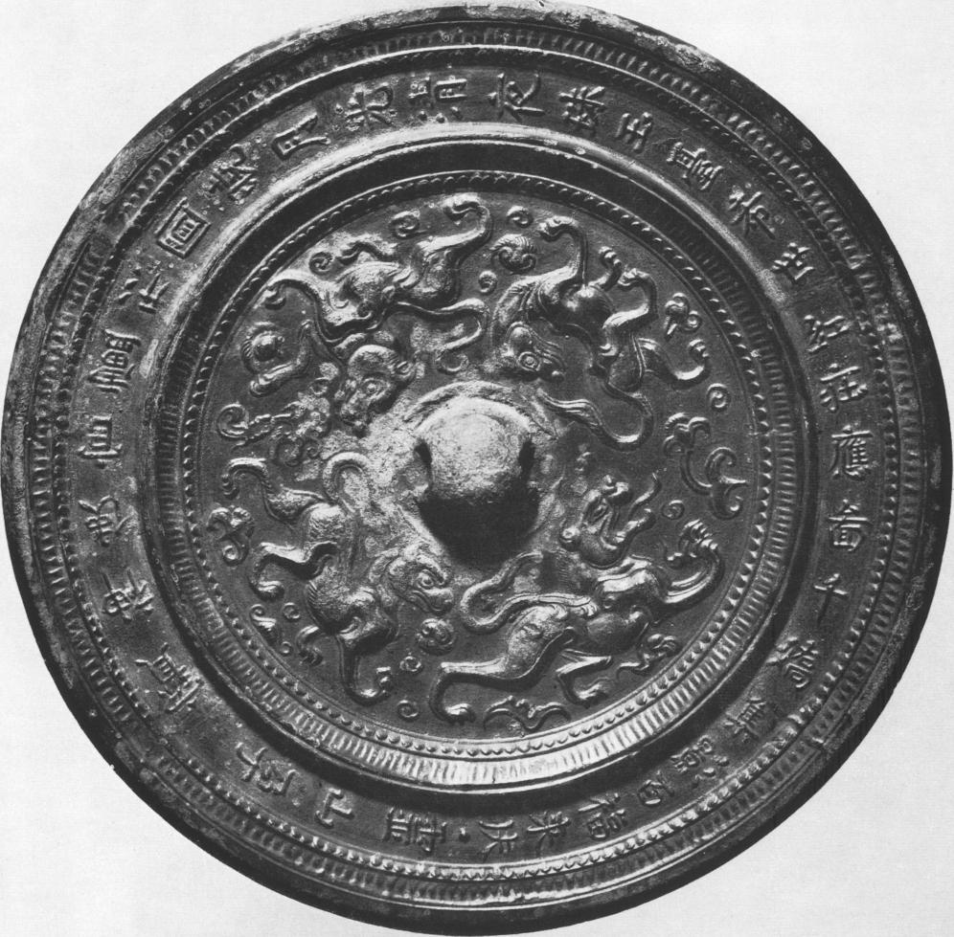

Fig. 7 Sui to early T'ang Mirror with Four Lions  
*Courtesy of the Smithsonian Institution, Freer Gallery of Art*

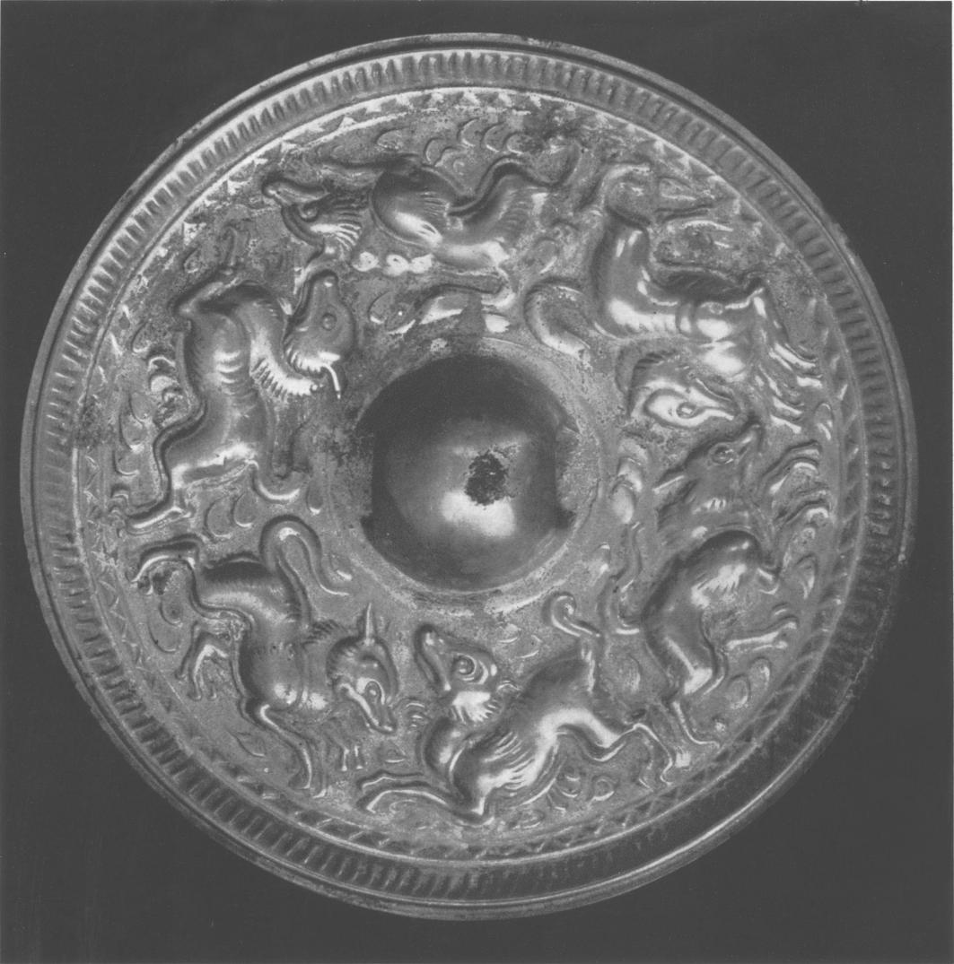

Fig. 8 Sui to early T'ang Mirror with Six Lions *Seattle Art Museum, Eugene Fuller Memorial Collection*

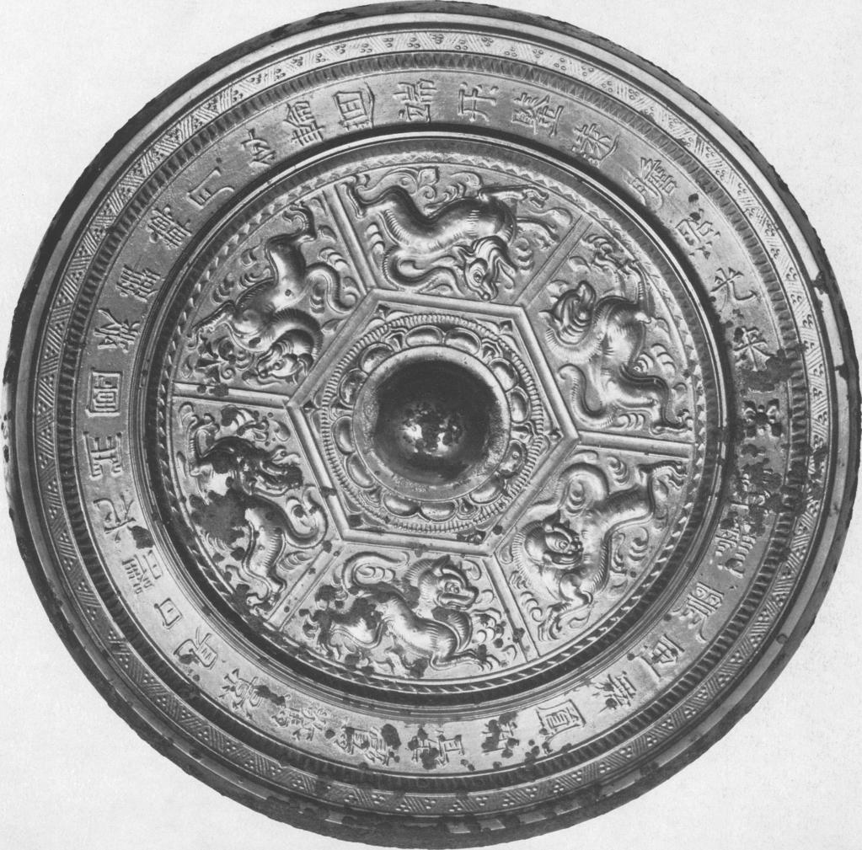

Fig. 9 Sui to early T'ang Mirror with Six Lions  
*Courtesy of the Smithsonian Institution, Freer Gallery of Art*

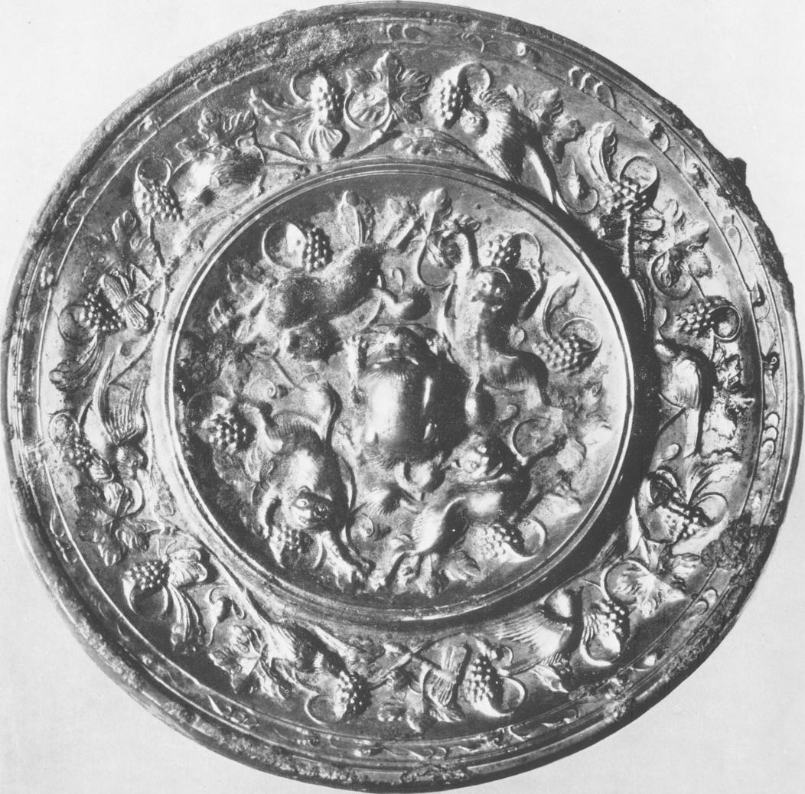

Fig. io T'ang Lion and Grape Mirror  
*Courtesy of the Art Institute of Chicago*

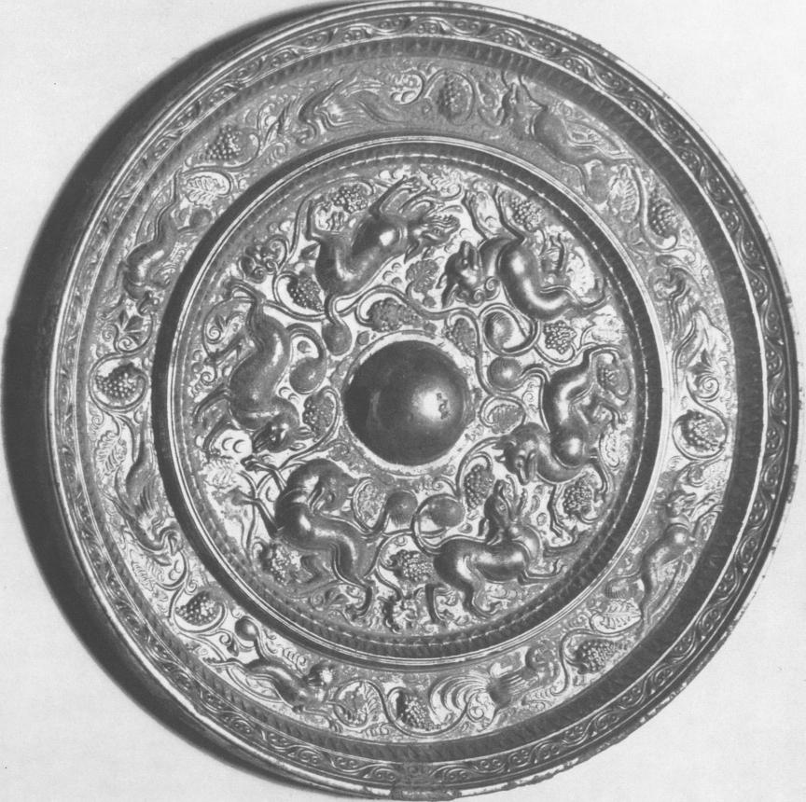

Fig. 1 1 T'ang Lion and Grape Mirror  
*The Minneapolis Institute of Arts*

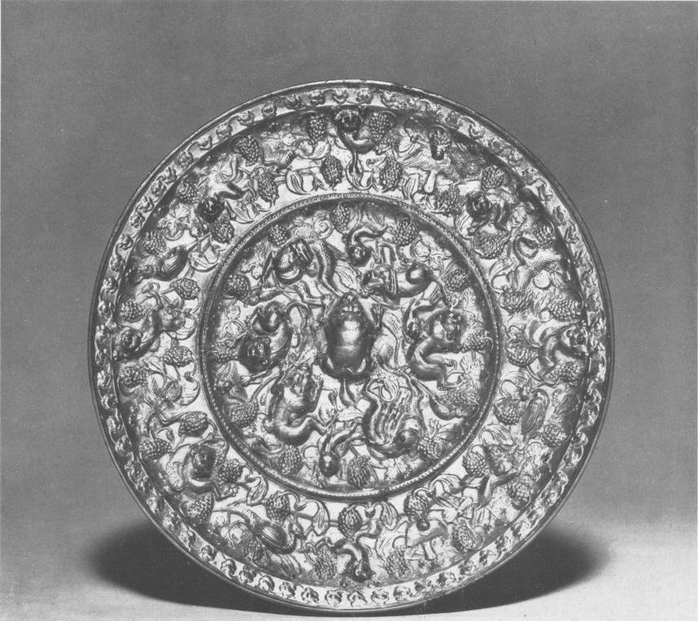

Fig. 12 T'ang Lion and Grape Mirror  
*Avery Brundage Collection*  
*M. H. De Young Memorial Collection, San Francisco, California*

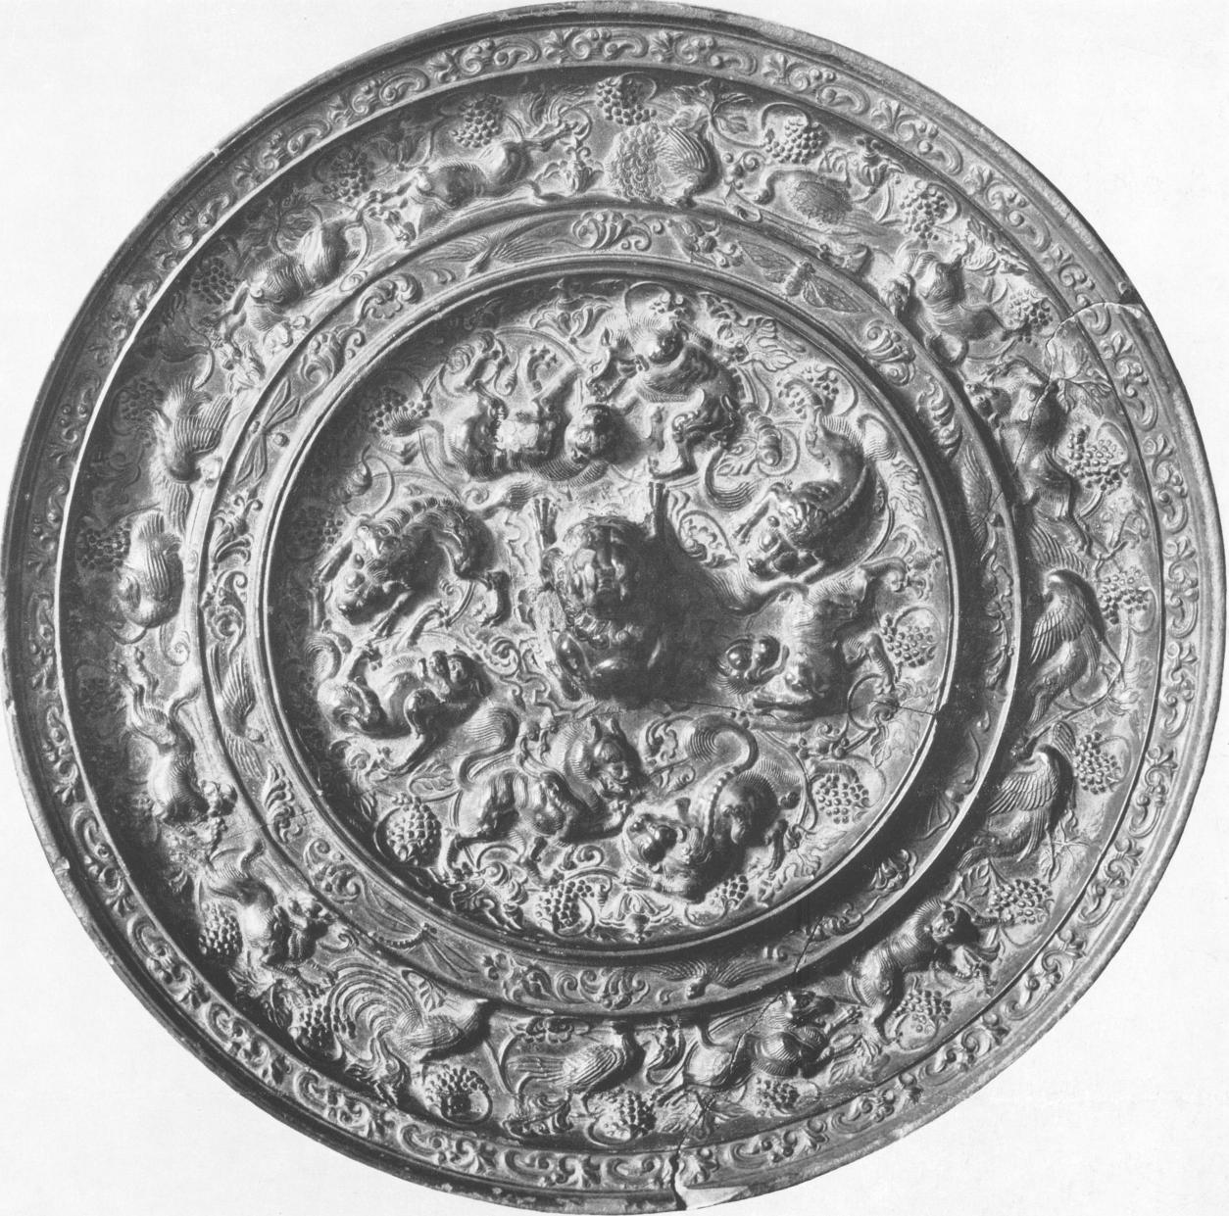

Fig. 13 'rang Lion and Grape Mirror  
*Courtesy of the Museum of Fine Arts, Boston (John Lowell Gardner Fund)*

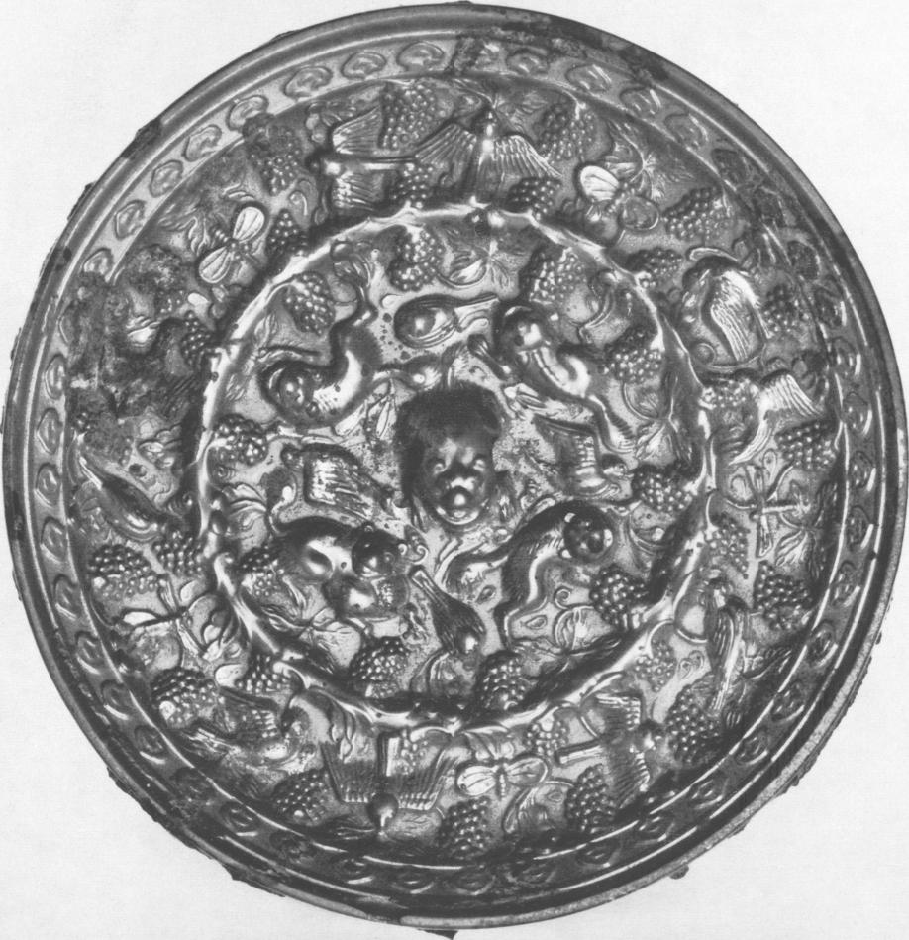

Fig. 14 T'ang Lion and Grape Mirror  
*Denver Museum of Art*